4. (25p) Answer all the questions on an electronic document.

The goal of this exercise is assessing the importance of the detector type on the response of a CA-CFAR. Consider an in-phase Gaussian noise vector (zero mean) ni and a quadrature Gaussian noise vector (zero mean) nq, each one with 1 μW power and having a length of 20 000 samples. Once the vectors are ready:

Then:

1. (10p) Simulate a CA-CFAR with 30 training cells (M) and no guard cells having a scaling factor α designed to get a false alarm probability of 0.02. In the same figure, plot in blue the output of the CA-CFAR (CUT) and the adaptive threshold (α/M) in red. How many false alarms have been detected?





423 False alarms were detected.

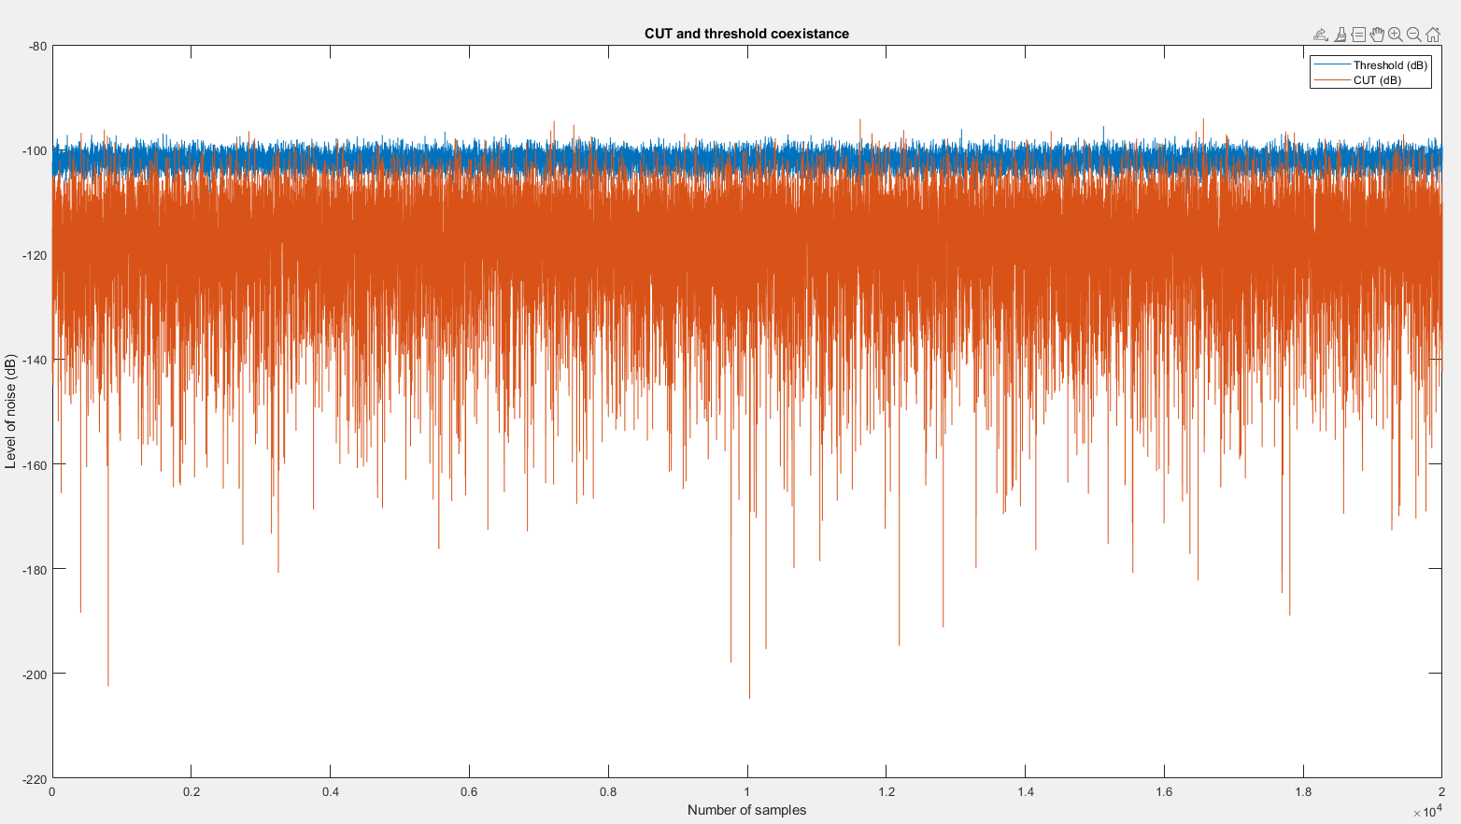

1. (10p) The CA-CFAR of the previous question used a square-law detector. Now, exchange the square-law detector by a linear detector (do not change α). In the same figure, plot in blue the output of the CA-CFAR and the adaptive threshold in red (α/M). How many false alarms have been detected?







Zero false alarm were detected!

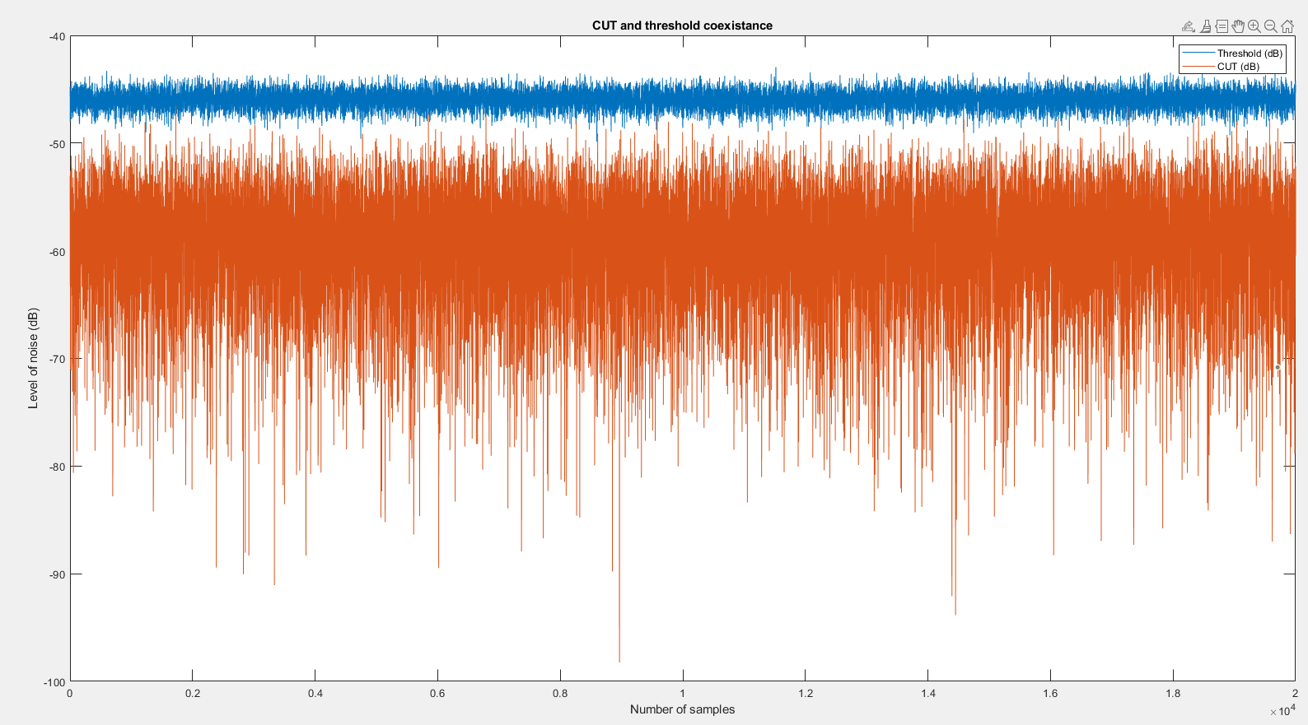

1. c) (5p) Make a brief comment explaining both results.

In the second linear result, zero false alarm were detected. A square law detector provides an output directly proportional to the power of the input electrical signal. As sucb with increased clutter spikyness, we should expect the false alarm probability Pfa to be largest for a linear, smaller for a square-law. Of course, because of the way that these averages vary, improved probability of detection Pd would be reversed; namely good for linear and intermediate for square-law.

In linear the threshold is way above the CUT as such nothing is detected.